Self-Care Strategies Worksheet
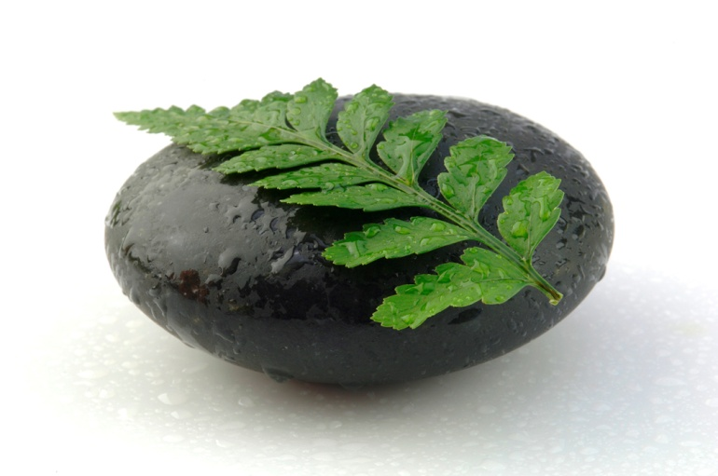
Value yourself:
I will value myself by committing to assessing my self-care strategies regularly.
_____________________________________________________________________
Signature Date
Refocus on the rewards:
Rewards of my studies include: 1._______________________
2._______________________
Minding your body and taking care of your physical self:
I will take care of my physical and emotional self in the following ways (check all those that apply):

__getting sufficient sleep
__spending time outside in nature
__exercising
__meditating
__seeking healthcare as needed
__eating well
__acknowledging physical needs (hunger, fatigue, etc.)
__practicing gratitude

Fostering Competent Community/Nurturance (Who has my back?):
I will give nurturance in my life by caring for the following people:
____________________________________________________
I will receive nurturance in my life by accepting the care from:
______________________________________________________

Create a flourishing environment:
When I return to my work setting, I will enhance my environment by bringing the following into my physical space (check all that apply):

__fresh flowers
__an inspiring quotation
__a meaningful piece of art
__a photo that brings me joy
__music
__comfortable chair
__an object that has special meaning for me
__Other?

Cultivate spirituality and mission:
I see my life and my work as having meaning and purpose. Three words that guide (or I want to guide) the way I lead my life are:
1._______________ 2._________________ 3.________________
Engage in cultural self-renewal:
This month, I will connect/reconnect with my cultural heritage by (circle all that apply):

__reading
__going to a festival/holiday
__listening to music __cooking
__connecting with a family member __chatting with an old friend
__other?

Foster creativity and growth (diversify):
Two (or more) new things I will try this month are:
1. ____________________________________________________
2. ____________________________________________________

~Adapted from: Norcross, J. C. & Guy, J. D. (2007). Leaving it at the office: Psychotherapist self-care. (New York: Guilford Press)

